QUESTION 1
The PART_CODE column in the SPARES table contains the following list of values:

PART_CODE
-----------------

A%_WQ123

A%BWQ123
AB_WQ123

Evaluate the following query:

SQL> SELECT part_code
FROM spares
WHERE part_code LIKE '%\%_WQ12%' ESCAPE '\';

Which statement is true regarding the outcome of the above query?

A. | It produces an error.
B. | It displays all values.
C. | It displays only the values A%_WQ123 and AB_WQ123.
D. | It displays only the values A%_WQ123 and A%BWQ123.
E. | It displays only the values A%BWQ123 and AB_WQ123.

Answer: D

Section: (none)

Explanation/Reference:

QUESTION 2

Which two statements are true regarding single row functions? (Choose two.)

A. | They accept only a single argument.
B. | They can be nested only to two levels.
C. | Arguments can only be column values or constants.
D. | They always return a single result row for every row of a queried table.
E. | They can return a data type value different from the one that is referenced.

Answer: DE

Section: (none)

Explanation/Reference:

QUESTION 3

When does a transaction complete? (Choose all that apply.)

A. | when a DELETE statement is executed
B. | when a ROLLBACK command is executed
C. | when a PL/SQL anonymous block is executed
D. | when a data definition language (DDL) statement is executed
E. | when a TRUNCATE statement is executed after the pending transaction

Answer: BDE

QUESTION 4

View the Exhibit to examine the description for the SALES and PRODUCTS tables.

You want to create a SALE_PROD view by executing the following SQL statement:

CREATE VIEW sale_prod
AS SELECT p.prod_id, cust_id, SUM(quantity_sold) "Quantity", SUM(prod_list_price) "Price" FROM products p, sales s
WHERE p.prod_id=s.prod_id
GROUP BY p.prod_id, cust_id;

Which statement is true regarding the execution of the above statement?

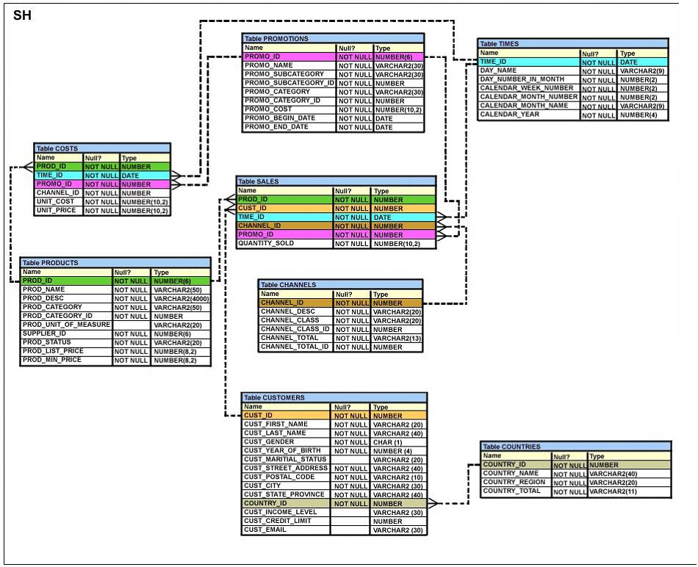

A. | The view will be created and you can perform DML operations on the view.
B. | The view will be created but no DML operations will be allowed on the view.
C. | The view will not be created because the join statements are not allowed for creating a view.
D. | The view will not be created because the GROUP BY clause is not allowed for creating a view.

Answer: B

QUESTION 5

View the Exhibit and examine the description for the CUSTOMERS table.

You want to update the CUST_INCOME_LEVEL and CUST_CREDIT_LIMIT columns for the customer with the CUST_ID 2360. You want the value for the CUST_INCOME_LEVEL to have the same value as that of the customer with the CUST_ID 2560 and the CUST_CREDIT_LIMIT to have the same value as that of the customer with CUST_ID 2566.

Which UPDATE statement will accomplish the task?

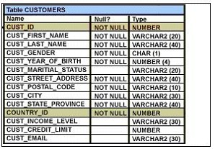

A. | UPDATE customers  SET cust_income_level = (SELECT cust_income_level  FROM customers  WHERE cust_id = 2560),  cust_credit_limit = (SELECT cust_credit_limit  FROM customers  WHERE cust_id = 2566)  WHERE cust_id=2360;
B. | UPDATE customers  SET (cust_income_level,cust_credit_limit) = (SELECT  cust_income_level, cust_credit_limit  FROM customers  WHERE cust_id=2560 OR cust_id=2566)  WHERE cust_id=2360;
C. | UPDATE customers  SET (cust_income_level,cust_credit_limit) = (SELECT  cust_income_level, cust_credit_limit  FROM customers  WHERE cust_id IN(2560, 2566)  WHERE cust_id=2360;
D. | UPDATE customers  SET (cust_income_level,cust_credit_limit) = (SELECT  cust_income_level, cust_credit_limit  FROM customers  WHERE cust_id=2560 AND cust_id=2566)  WHERE cust_id=2360;

Answer: A

QUESTION 6

View the Exhibit and examine the structure of the PROMOTIONS table.

Evaluate the following SQL statement:

SQL>SELECT promo_category, AVG(promo_cost) Avg_Cost, AVG(promo_cost)*.25 Avg_Overhead FROM promotions
WHERE UPPER(promo_category) IN ('TV', 'INTERNET','POST') GROUP BY Avg_Cost ORDER BY Avg_Overhead; The above query generates an error on execution. Which clause in the above SQL statement causes the error?

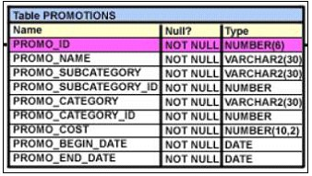

A. | WHERE
B. | SELECT
C. | GROUP BY
D. | ORDER BY

Answer: C

QUESTION 7

View the Exhibits and examine the structures of the PRODUCTS, SALES, and CUSTOMERS tables.

You need to generate a report that gives details of the customer's last name, name of the product, and the quantity sold for all customers in 'Tokyo'.

Which two queries give the required result? (Choose two.)

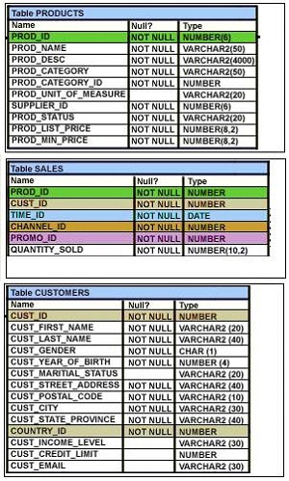

A. | SELECT c.cust_last_name,p.prod_name, s.quantity_sold  FROM sales s JOIN products p  USING(prod_id)  JOIN customers c  USING(cust_id)  WHERE c.cust_city='Tokyo';
B. | SELECT c.cust_last_name, p.prod_name, s.quantity_sold  FROM products p JOIN sales s JOIN customers c  ON(p.prod_id=s.prod_id)  ON(s.cust_id=c.cust_id)  WHERE c.cust_city='Tokyo';
C. | SELECT c.cust_last_name, p.prod_name, s.quantity_sold  FROM products p JOIN sales s  ON(p.prod_id=s.prod_id)  JOIN customers c  ON(s.cust_id=c.cust_id)  AND c.cust_city='Tokyo';
D. | SELECT c.cust_id,c.cust_last_name,p.prod_id, p.prod_name, s.quantity_sold FROM products p JOIN sales s  USING(prod_id)  JOIN customers c  USING(cust_id)  WHERE c.cust_city='Tokyo';

Answer: AC

QUESTION 8

Which statement is true regarding subqueries?

A. | The LIKE operator cannot be used with single-row subqueries.
B. | The NOT IN operator is equivalent to IS NULL with single-row subqueries.
C. | =ANY and =ALL operators have the same functionality in multiple-row subqueries.
D. | The NOT operator can be used with IN, ANY, and ALL operators in multiple-row subqueries.

Answer: D

QUESTION 9

Which three SQL statements would display the value 1890.55 as $1,890.55? (Choose three.)

A. | SELECT TO_CHAR(1890.55,'$0G000D00')  FROM DUAL;
B. | SELECT TO_CHAR(1890.55,'$9,999V99')  FROM DUAL;
C. | SELECT TO_CHAR(1890.55,'$99,999D99')  FROM DUAL;
D. | SELECT TO_CHAR(1890.55,'$99G999D00')  FROM DUAL;
E. | SELECT TO_CHAR(1890.55,'$99G999D99')  FROM DUAL;

Answer: ADE

QUESTION 10

View the Exhibit and examine the structure of the CUSTOMERS table.

Which statement would display the highest credit limit available in each income level in each city in the CUSTOMERS table?
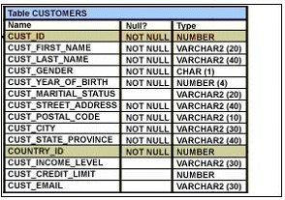

A. | SELECT cust_city, cust_income_level, MAX(cust_credit_limit) FROM customers  GROUP BY cust_city, cust_income_level, cust_credit_limit;
B. | SELECT cust_city, cust_income_level, MAX(cust_credit_limit) FROM customers  GROUP BY cust_city, cust_income_level;
C. | SELECT cust_city, cust_income_level, MAX(cust_credit_limit) FROM customers  GROUP BY cust_credit_limit, cust_income_level, cust_city;
D. | SELECT cust_city, cust_income_level, MAX(cust_credit_limit) FROM customers  GROUP BY cust_city, cust_income_level, MAX (cust_credit_limit);

Answer: B

QUESTION 11

Which CREATE TABLE statement is valid?

A. | CREATE TABLE ord_details  (ord_no NUMBER(2) PRIMARY KEY,  item_no NUMBER(3) PRIMARY KEY,  ord_date DATE NOT NULL);
B. | CREATE TABLE ord_details  (ord_no NUMBER(2) UNIQUE, NOT NULL,  item_no NUMBER(3),  ord_date DATE DEFAULT SYSDATE NOT NULL);
C. | CREATE TABLE ord_details  (ord_no NUMBER(2) ,  item_no NUMBER(3),  ord_date DATE DEFAULT NOT NULL,  CONSTRAINT ord_uq UNIQUE (ord_no),  CONSTRAINT ord_pk PRIMARY KEY (ord_no));
D. | CREATE TABLE ord_details  (ord_no NUMBER(2),  item_no NUMBER(3),  ord_date DATE DEFAULT SYSDATE NOT NULL,  CONSTRAINT ord_pk PRIMARY KEY (ord_no, item_no));

Answer: D

QUESTION 12
Evaluate the following SQL statement:

SQL> SELECT cust_id, cust_last_name "Last Name"
FROM customers
WHERE country_id = 10
UNION
SELECT cust_id CUST_NO, cust_last_name
FROM customers
WHERE country_id = 30;

Which ORDER BY clauses are valid for the above query? (Choose all that apply.)

A. | ORDER BY 2,1
B. | ORDER BY CUST_NO
C. | ORDER BY 2,cust_id
D. | ORDER BY "CUST_NO"
E. | ORDER BY "Last Name"

Answer: ACE

QUESTION 13

Which is the valid CREATE TABLE statement?

A. | CREATE TABLE emp9$# (emp_no NUMBER(4));
B. | CREATE TABLE 9emp$# (emp_no NUMBER(4));
C. | CREATE TABLE emp*123 (emp_no NUMBER(4));
D. | CREATE TABLE emp9$# (emp_no NUMBER(4), date DATE);

Answer: A

QUESTION 14
The SQL statements executed in a user session are as follows:

SQL> CREATE TABLE product
(pcode NUMBER(2),
pname VARCHAR2(10));
SQL> INSERT INTO product VALUES (1, 'pen');
SQL> INSERT INTO product VALUES (2,'pencil');
SQL> SAVEPOINT a;
SQL> UPDATE product SET pcode = 10 WHERE pcode = 1;
SQL> SAVEPOINT b;
SQL> DELETE FROM product WHERE pcode = 2;
SQL> COMMIT; SQL> DELETE FROM product WHERE pcode=10;

Which two statements describe the consequences of issuing the ROLLBACK TO SAVE POINT a command in the session? (Choose two.)

A. | The rollback generates an error.
B. | No SQL statements are rolled back.
C. | Only the DELETE statements are rolled back.
D. | Only the second DELETE statement is rolled back.
E. | Both the DELETE statements and the UPDATE statement are rolled back.

Answer: AB

QUESTION 15
View the Exhibit and examine the description of SALES and PROMOTIONS tables. You want to delete rows from the SALES table, where the PROMO_NAME column in the PROMOTIONS table has either blowout sale or everyday low price as values. Which DELETE statements are valid? (Choose all that apply.)

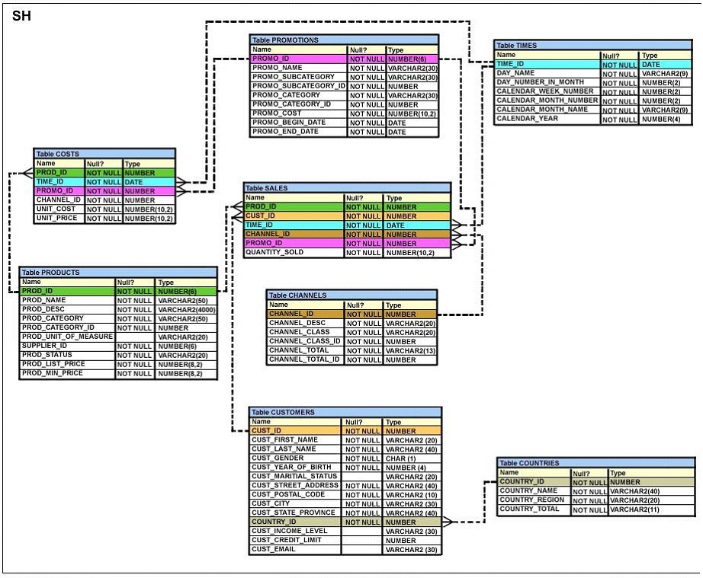

A. | DELETE  FROM sales  WHERE promo_id = (SELECT promo_id  FROM promotions  WHERE promo_name = 'blowout sale')  AND promo_id = (SELECT promo_id  FROM promotions  WHERE promo_name = 'everyday low price');
B. | DELETE  FROM sales  WHERE promo_id = (SELECT promo_id  FROM promotions  WHERE promo_name = 'blowout sale')  OR promo_id = (SELECT promo_id  FROM promotions  WHERE promo_name = 'everyday low price');
C. | DELETE  FROM sales  WHERE promo_id IN (SELECT promo_id  FROM promotions  WHERE promo_name = 'blowout sale'  OR promo_name = 'everyday low price');
D. | DELETE  FROM sales  WHERE promo_id IN (SELECT promo_id  FROM promotions  WHERE promo_name IN ('blowout sale','everyday low price'));

Answer: BCD

